Tenda W6-S – How to configure Network settings

- Click on “Network”, double click “LAN Setup” to set up the IP Address Type in Static or Dynamic.

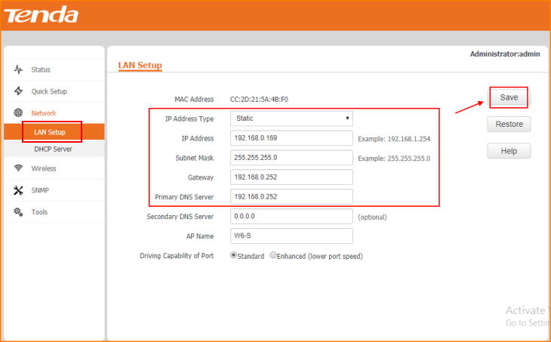

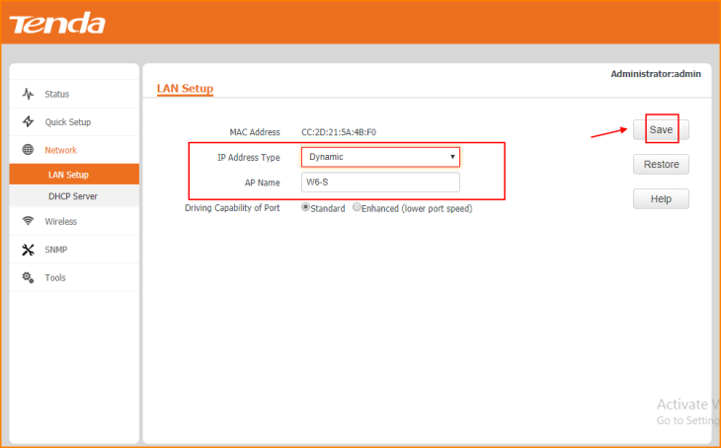

Note: Remember to “Save” the configuration.

- Click on “DHCP Server” and Enable the option of “Enable” to set up a Server for your own.

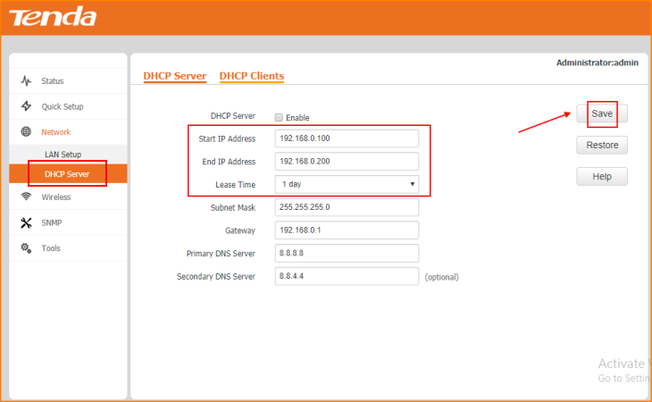

Note: Remember to “Save” the configuration.

- Click on “DHCP Server” to set the “Lease Time”.

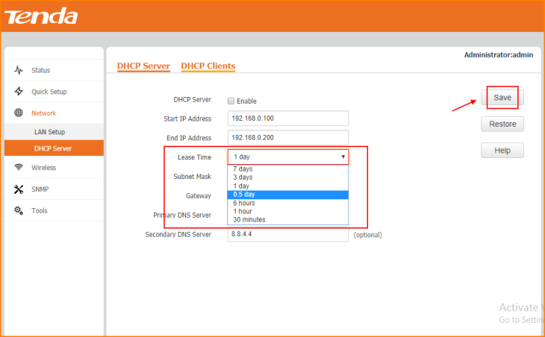

Note: Remember to “Save” the configuration.

